PROJECT PROPOSAL
SUPERSTORE SALES ANALYSIS AND VISUALIZATION USING PYTHON
Data Cleaning, Exploratory Data Analysis and Business Insights
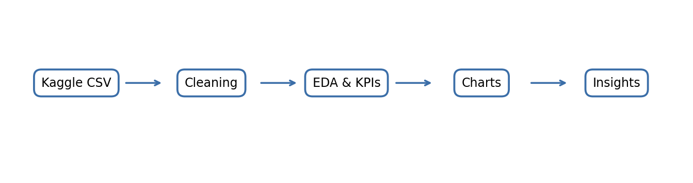
Submitted By
Dax Prajaapati
College: Indus University
Programme: B.Tech
Project Type: Individual Project
Academic Year: 2026–27
Dataset: Superstore Dataset Final (Kaggle)

1. Project Definition
The project aims to analyze retail transaction data from the Superstore Dataset using Python. It will examine sales, profit, product categories, customer segments, geographical regions, discounts, and changes over time. Data cleaning, exploratory data analysis (EDA), key performance indicator (KPI) calculations, and visualizations will be used to turn raw transaction records into understandable business insights.

2. Problem Statement
Retail sales data can contain many records and columns, making it difficult to identify which products and regions perform well, how profitability changes over time, and whether discount levels are associated with losses. Total sales alone do not show the full business picture. This project will organize and analyze the dataset to identify patterns in sales and profit and provide evidence-based recommendations. The analysis will describe associations and trends; it will not claim causation unless supported by additional evidence.

3. Objectives
- Load the Superstore CSV dataset and inspect its structure.
- Clean and validate data types, dates, missing values, and duplicate records.
- Calculate total sales, total profit, profit margin, order count, quantity sold, and average order value where fields are available.
- Compare sales and profit by product category, subcategory, region, customer segment, and product.
- Analyze monthly and yearly sales trends.
- Examine discount and profitability patterns.
- Create clear charts and summarize findings.
- Document the work in a Python notebook and GitHub repository.
- Optionally create an interactive dashboard using Streamlit.

4. Dataset Use Case
Dataset name: Superstore Dataset Final
Source: Kaggle
Dataset URL: https://www.kaggle.com/datasets/vivek468/superstore-dataset-final

The dataset commonly contains retail order information such as order date, shipping date, customer and segment details, region and state, product category and subcategory, sales, quantity, discount, and profit. The exact column names and available fields will be verified after downloading the file. The project will use the dataset for descriptive analytics, comparisons, trend analysis, and visualization.

5. Proposed Analysis
A. Overall business KPIs: calculate total sales, total profit, profit margin, unique orders, total quantity, unique customers, average order value, and average discount when the relevant columns are available.
B. Time analysis: aggregate sales by month and year to identify changes and possible seasonal patterns.
C. Category analysis: compare sales and profit across product categories and subcategories.
D. Regional analysis: compare sales and profitability across available regions and states.
E. Product analysis: rank products by aggregated profit and identify products with the largest positive or negative profit.
F. Customer segment analysis: compare sales and profit for each customer segment.
G. Discount analysis: examine whether higher discounts are associated with lower profit or losses.
H. Shipping analysis (optional): compare sales and profit across shipping modes.

6. Visualization Graphs and Expected Outcomes
1. Monthly Sales Trend — Line Chart: shows how sales vary over time.
2. Sales and Profit by Category — Grouped Bar Chart: compares category performance.
3. Sales and Profit by Region — Bar Chart: highlights regional differences.
4. Top and Bottom 10 Products by Profit — Horizontal Bar Charts: identifies high- and low-profit products.
5. Discount vs Profit — Scatter Plot: explores the relationship between discount rates and profit.
6. Sales by Customer Segment — Bar Chart: compares segment contribution.
7. Monthly Sales Heatmap — Heatmap: compares monthly patterns across years.
8. KPI Summary — Table or dashboard cards: provides a quick overview of business performance.
All visual examples included in this proposal are illustrative placeholders, not actual findings from the dataset.
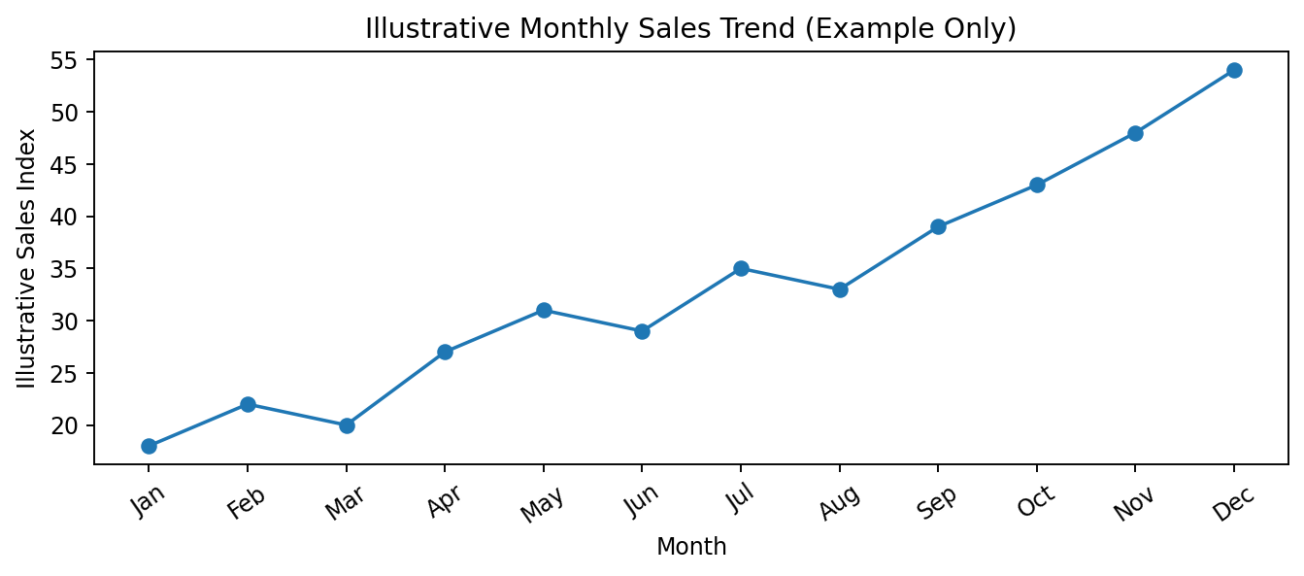
Illustrative example only — actual chart will be generated from the downloaded dataset.
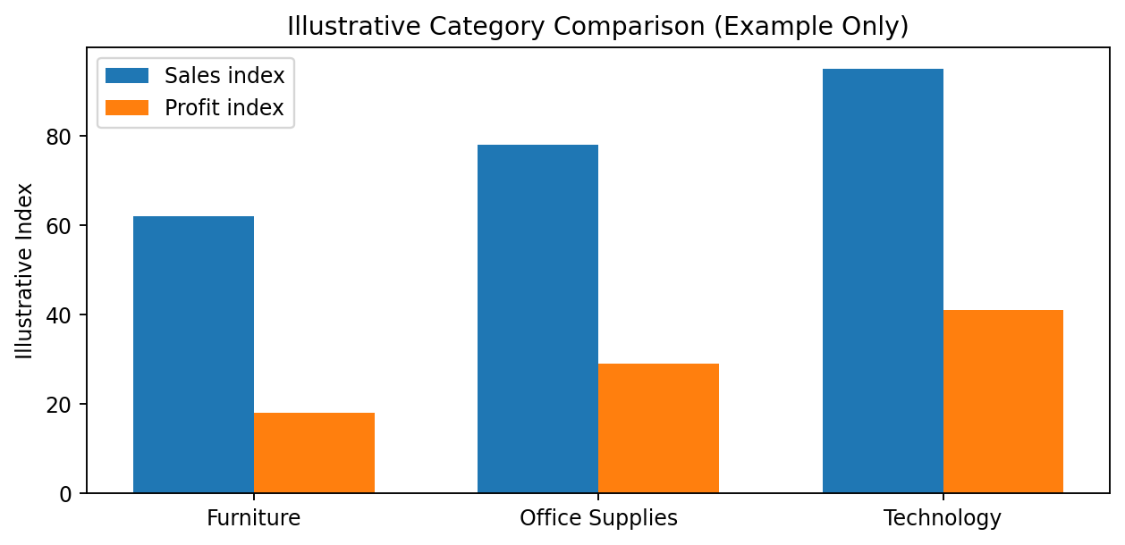
Illustrative example only — actual chart will be generated from the downloaded dataset.
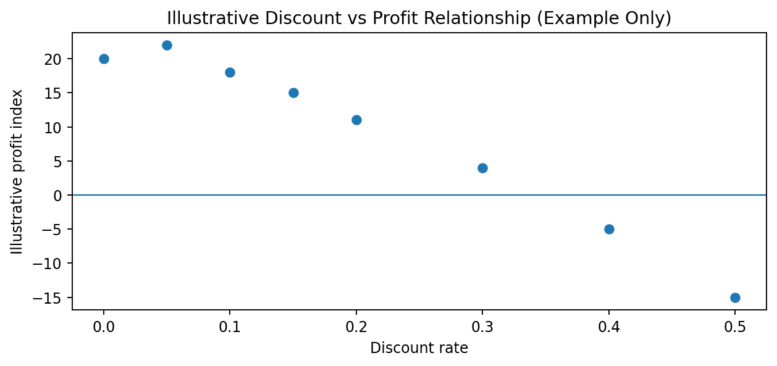
Illustrative example only — actual chart will be generated from the downloaded dataset.

7. Tools and Technologies
- Python 3 — main programming language.
- Google Colab — recommended notebook environment for writing and running code in a browser.
- Pandas — loading CSV files, data cleaning, filtering, grouping, and aggregation.
- NumPy — numerical operations and calculations.
- Matplotlib — line charts, bar charts, and other visualizations.
- Seaborn — statistical charts and heatmaps.
- Kaggle — source for downloading the dataset.
- Git and GitHub — version control, source-code storage, and project documentation.
- Streamlit (optional) — interactive dashboard development.
The core project can be completed using Google Colab, Python, Pandas, NumPy, Matplotlib, and Seaborn. VS Code is an alternative local development environment, but it is not required if Google Colab is used.
Recommended environment: Google Colab. VS Code may be used as an alternative for local development.

8. Methodology
1. Data collection: download the CSV file from Kaggle.
2. Data inspection: review column names, row counts, data types, missing values, and duplicates.
3. Data preprocessing: parse date columns, convert numeric columns, remove exact duplicate rows where appropriate, and document remaining missing values.
4. Exploratory analysis: calculate summary statistics and KPIs.
5. Grouped analysis: compare time periods, products, categories, regions, and customer segments.
6. Visualization: create charts using Matplotlib and Seaborn.
7. Interpretation: explain the trends observed and identify possible business implications.
8. Reporting: save the notebook, outputs, README, and final report.

9. System Requirements
Hardware: a laptop or desktop with internet access; 4 GB RAM minimum is suitable for this dataset, with 8 GB recommended.
Software: web browser and Google Colab, or Python 3 with Jupyter/VS Code installed locally.
Libraries: pandas, numpy, matplotlib, seaborn; streamlit is optional.
Storage: enough space for the CSV dataset, notebook, charts, and exported results.

10. Expected Outcomes
The project is expected to produce a cleaned dataset, a runnable Python notebook, a KPI summary, visualizations for sales and profitability, category and region comparisons, product rankings, discount analysis, and a written summary of findings. The analysis may reveal high-performing categories or regions and areas needing further review. Specific conclusions will be reported only after the actual dataset has been processed.

11. Project Limitations
The findings depend on the quality and completeness of the downloaded dataset. Historical data may not represent current market conditions. The dataset may not contain all costs, inventory information, or operational factors needed to explain profitability fully. Correlation between discounts and profit does not prove that discounts caused a loss. Any forecasting or interactive dashboard feature is optional and may require additional validation.

12. Proposed Timeline
Week 1: Download the dataset, inspect the columns, and perform data cleaning.
Week 2: Calculate KPIs and conduct exploratory, category, region, and customer analysis.
Week 3: Create and validate visualizations and interpret patterns.
Week 4: Complete the report, organize GitHub documentation, and prepare the presentation. An optional dashboard can be added if time permits.

13. GitHub Repository and Documentation
A GitHub repository will be used to store the project notebook, README file, requirements.txt, visualizations, and final findings. The repository link will be added after it is created. The dataset itself may be referenced by its Kaggle source rather than redistributed, depending on its license and usage terms.

14. Conclusion
This project will demonstrate how Python-based data analysis can convert retail transaction records into useful business information. By combining data cleaning, KPI calculations, exploratory analysis, and visualization, it will study sales and profit patterns across time, products, regions, and customer segments. The final notebook and report will present data-supported observations and recommendations.

15. References
1. Vivek468, “Superstore Dataset Final,” Kaggle: https://www.kaggle.com/datasets/vivek468/superstore-dataset-final
2. Pandas documentation: https://pandas.pydata.org/docs/
3. NumPy documentation: https://numpy.org/doc/
4. Matplotlib documentation: https://matplotlib.org/stable/
5. Seaborn documentation: https://seaborn.pydata.org/
6. Google Colab: https://colab.research.google.com/
7. GitHub documentation: https://docs.github.com/

